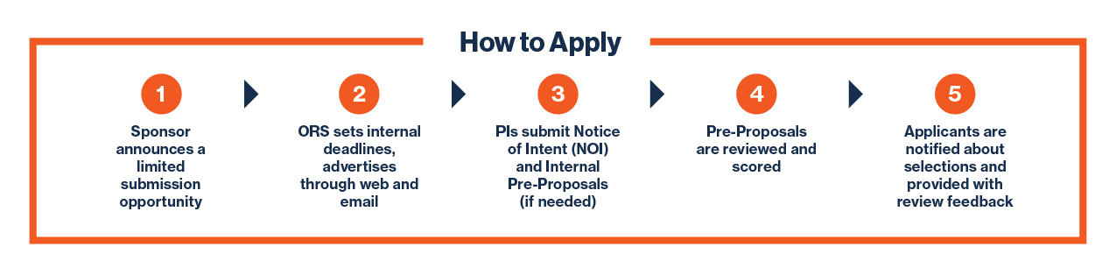
Process Overview
SRI sets internal deadlines, advertises through web and email

IDENTIFICATION AND DISSEMINATION PROCESS
The Office of Strategic Research Initiatives (SRI) makes every effort to identify relevant limited submission opportunities and to disseminate these opportunities in a timely manner through several mediums:
- Announcement Emails | Notifications are sent on the limited submissions listserv. To be added to the Limited Submissions listserv, please contact us at limitedsubmissions@utsa.edu
- Limited Submissions Funding Opportunities | Funding opportunities are often updated weekly. Visit this site regularly to stay apprised of new announcements and deadlines.
- Forwarded/Targeted Emails | Discipline-specific opportunities are often forwarded through the Colleges’ Associate Deans for Research, Senior Grant Development Coordinators, or Research Service Centers.

INTERNAL COMPETITION PROCESS
How to submit your Notice of Intent (NOI)
- Send your NOI to limitedsubmissions@utsa.edu. Include:
  - Subject line: Program and sponsor name NOI
  - Proposed project title
  - A brief 3-5 sentence abstract of the project
  - List of key personnel and associated organizations
- Researchers will receive an email confirmation of NOI receipt
How to submit your Pre-Proposal
- Submit internal Pre-Proposals to limitedsubmissions@utsa.edu.
Unless otherwise noted, upload as a single pdf that includes:
- 4-page project overview (single-spaced, 1” margins, Arial 11pt or greater font)
- 2-page biographical sketch for each key project personnel
- References (no page limit)
- A signed Limited Submissions Resources Commitment Form (only for opportunities that require cost-share/match (see Cost-Share section below) or other resource commitments (i.e. renovation of space))
Review and Selection
- Internal Pre-Proposals are collected, reviewed for compliance and passed on for review/scoring by reviewers who are provided an evaluation matrix based on the evaluation criteria listed in the program solicitation or used for all programs administered by that sponsor.
  - External Review is utilized for the majority of limited submission competitions. SRI currently contracts with Oak Ridge Associated Universities (ORAU) to facilitate a scientific review process. Each application is scored by up to three external peer reviewers and the top-ranked proposal is chosen to move forward.
  - Internal Review is primarily implemented for private opportunities that merit an institutional relationship with a funder and/or that will be evaluated by a lay or philanthropically-minded audience. An internal ad-hoc panel of reviewers is formed in collaboration with UTSA’s Office of Corporate & Foundation Engagement.
  - Institutional Priority Selection is made in cases where VPREDKE selects the PI based on a prioritized institutional need.
  - Automatic Selection is made when there is only one eligible NOI received by the NOI deadline date. Proposal review comments and scores are not provided.
- For all selected pre-proposals, researchers are required to provide immediate notice of any incremental changes (i.e. Lead PI change, budgetary adjustments, no longer submitting, etc.).

SHORT NOTICE OPPORTUNITIES
When we first learn of a limited submission opportunity within 45 days of the sponsor deadline, our approach changes. The limited submissions team will:
- Check with the Research Service Centers to ensure that no other PIs or teams have begun preparing to apply to the opportunity. If another team has begun work on a proposal, ORS will determine whether to quickly compete the opportunity or to allow the team already in progress to continue.
- If no other teams have initiated the proposal development process, we will invite the team that inquired about the opportunity to go forward and submit a proposal.
- We update the Limited Submissions website to indicate that a team has been selected.

COST-SHARE OR MATCHING FUNDS
When the funding agency has implemented a cost-share or matching funds requirement for the award, applicants must identify an allowable funding source(s) at the time of pre-proposal submission. The source(s) of funds should be outlined on the Limited Submissions Resources Commitment Form and uploaded with your application materials by the pre-proposal submission deadline.
Internal Deadlines
All Notices of Intent (NOIs) and Internal Pre-Proposals must be received by 11:59 pm on the deadline date to be considered. If no notices of intent are received by the deadline, interested researchers are encouraged to submit as soon as possible after the deadline. Deadline dates for posted funding opportunities can be found on the Limited Submissions Funding Opportunities web page.
Current & Expired Opportunities
Visit the Limited Submissions Funding Opportunities website to find a list of the funding opportunities that SRI has curated as most relevant to UTSA researchers. Please note that this list is not comprehensive. Anyone interested in applying to a limited program that is not currently posted on our website should contact limitedsubmissions@utsa.edu immediately. ORS will review the opportunity and determine the next steps.

